IHE Work Item Proposal (Detailed)

# Proposed Work Item: CDA Care Team Section (with entries)

Proposal Editor: Emma Jones, George Dixon, Daniel Venton (Allscripts)

Work item Editor: Emma Jones, George Dixon, Daniel Venton (Allscripts)

Date: February 26, 2019

Version: 1.0

Domain: PCC

# Summary

A CDA Care Team Section template with structured entries provides the ability to share concise information about a patient’s care team. This is needed to assist in preventing fragmented care for individuals which may result in healthcare inefficiencies, poor communication, poor outcomes and safety issues. A structured section template will improve care coordination by providing the means of making care team attributes computable thus enhancing semantic interoperability.

# The Problem

<Summarize the integration problem. What doesn’t work, or what needs to work?>

Currently, there are attempts to identify caregivers and to organize care providers for individuals by using paper or text only component of a CDA document. Current use of participant elements in a CDA document is not truly representative of a patient’s care team. Some care management platforms that in use today attempt to define care teams but they are propriety and supported by single organization where the patient is receiving care.

Also, there is an identified gap in standards alignment that is needed to support clinical workflow. Currently, FHIR CareTeam resources is in the process of being aligned to support HL7 Care Team Domain Analysis Model constructs. There is not an existing means of accomplishing the same for CDA implementations.

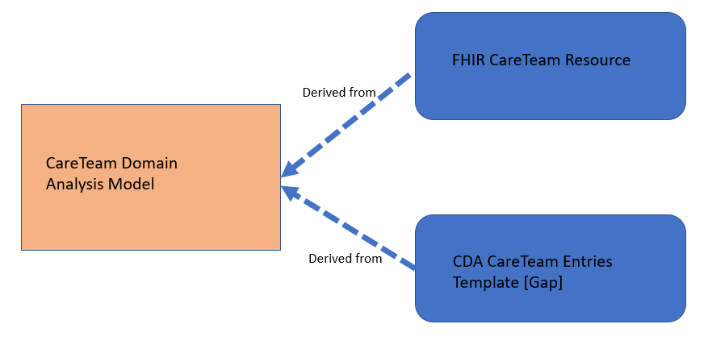

<Describe the Value Statement: What is the underlying cost incurred by the problem and what is to be gained by solving it? If possible provide quantifiable costs, or data to demonstrate the scale of the problem.>

This proposal provides a means of capturing and sharing a true representation of a patient’s care team and applicable attributes as needed to enhance care provision, communication and improve care coordination.

# Key Use Case

<Describe a short use case scenario from the user perspective. The use case should demonstrate the integration/workflow problem. Feel free to add a second use case scenario demonstrating how it “should” work. Try to indicate the people/systems, the tasks they are doing, the information they need, and where the information should come from.>

The following use case is based on the [Betsy Johnson Storyboard](http://confluence.hl7.org/display/LHS/Betsy+Johnson+Storyboard). Participants in the below storyboard are members of Betsy’s care team (depicted in italicized, underlined). If the below information is represented in a CDA document as it exists today, some of the participants may not a) exist in the document b) unable to be represented with their applicable role.

### **Scenario 1**

Betsy Johnson, a 60 year-old widow and retired teacher lives in Springfield, IL. She lives a few streets from her daughter (Daisy), *who is her caregiver, assisting with her healthcare and legal needs.*

Betsy has a son, Sunny, who lives in Orlando, Florida. Betsy stays with her son for a couple of months each winter, during which *her son replaces his sister as Betsy’s caregiver*.

### **Scenario 2**

Betsy has Type 2 Diabetes diagnosed 20 years ago, dyslipidemia and peripheral vascular disease diagnosed 4 years ago, congestive heart failure diagnosed 2 years ago, and anxiety diagnosed nearly 1 year ago.

Her medical conditions are managed *by her primary care provider, Dr John Carlson* of Rose Valley Primary Care. She was referred by Dr Carlson to *her dietitian/nutritionist (Maria Gonzales, RD)* for education and management of her diet specific to her diabetes, dyslipidemia, and weight issue related to her sedentary lifestyle.

Due to the complexity of her health conditions, *a care coordinator from Rose Valley Primary Care, Deborah Smith*, is assigned to coordinate and assist in managing Betsy’s care.

### **Scenario 3**

Betsy started to develop progressive chronic kidney disease (CKD) about 10 years ago. Her chronic renal condition is continuously managed by a *multi-disciplinary nephrology team* (functioning as in a whole as a member of the *composite care team lead by Dr Carlson*). The *nephrology team is led by Dr Vice Jones,* chief nephrologist of the *Nephrology Clinic*. Given the complexity of Betsy’s condition, the *nephrology clinic’s care coordinator, Sarah King*, is assigned to coordinate the nephrology care and liaise with the care coordinator from Rose Valley Primary Clinic to ensure that management plans and care activities delivered by the nephrology team and the composite team from Rose Valley are integrated and coordinated as much as possible.

### **Scenario 4**

Because of her congestive heart failure and diabetic retinopathy resulting in loss of vision, Betsy has significant difficulties in managing her activities of daily living. Deborah Smith, care coordinator from Rose Valley Primary Care initiated *two community services* to provide the appropriate level of support to Betsy so that she can continue to live relatively independently at home as she prefers. The two services are *meals-on-wheels and home care services*

# Standards & Systems

<List existing systems that are/could be involved in the problem/solution.>

<If known, list specific components of standards which might be relevant to the solution.>

Standards

* CDA R2
* IHE PCC Medical Document
* Consolidated CDA 2.1

Systems

* EHR
* PHR
* Patient Portal
* HIE

# Technical Approach

<This section can be very short. Feel free to include as much or as little detail as you like. The Technical Committee will flesh it out when doing the effort estimation.>

<Outline how the standards could be used and refined to solve the problems in the Use Cases. The Technical Committee will be responsible for the full design and may choose to take a different approach, but a sample design is a good indication of feasibility.>

This updated section template will define CDA concepts that can be used to create care team section constructs needed for a CDA document (the existing Care Team Section is a text only section). This approach will provide optional entries for the existing care team section. The new entries constructs will be a functional representation of the HL7 Care Team Domain Analysis Model concepts. It will also attempt to provide structures to support C-CDA mapping to FHIR CareTeam resource. The following is a possible example of the proposed constructs:

***Care Team Section (entries optional)***

|  |  |
| --- | --- |
| **Contained By:** | **Contains:** |
|  | Care Team Organizer |
|  | **Contains:** |
|  | Care Team Member Act |

New actors

<List possible new actors>

* No new actors

Existing actors

<Indicate what existing actors might be affected by the profile.>

* Content Creator
* Content Consumer

New Transactions (standards used)

<Describe possible new transactions (indicating what standards would likely be used for each. Transaction diagrams are very helpful here. Feel free to go into as much detail as seems useful.>

* No new transactions

<Point out any key issues or design problems. This will be helpful for estimating the amount of work.>

<If a phased approach would make sense indicate some logical phases. This may be because standards are evolving, because the problem is too big to solve at once, or because there are unknowns that won’t be resolved soon.>

<Indicate how existing / /transactions might need to be modified.>

Impact on existing content profiles

<Indicate how existing profiles might need to be modified.>

* The applicable Care Team section with structured entries can be added CDA document ‘open’ templates

New integration profiles needed

<Indicate how existing profiles might need to be modified.>

Breakdown of tasks that need to be accomplished

<A list of tasks would be helpful for the technical committee who will have to estimate the effort required to design, review and implement the profile.>

# Risks

<List technical or political risks that will need to be considered to successfully field the profile.>

HL7 Care Team Domain Analysis Model is in the process of going through an informative ballot. Therefore, any future DAM updates that relates to this template, will need to be handled as change proposals.

# Open Issues

# Effort Estimates